Application to Cancel Course

Application opening hour:
November 11 (Mon.) (10:00a.m.) ~December 20(Fri.) (6:00 p.m.)
Note

Please read instructions below before cancelling course

- After the course is cancelled, the number of credits taken cannot be lower than the minimum credit requirement by year as listed in rule 15 of the student handbook. Those who do not meet credit requirements are ineligible for application. Fourth year students are exempt if this does not affect the number of credits required for graduation.

＊The minimum credit requirement for each year and degree are as below:
Degree | Minimum Cr | Degree | Minimum Cr
University years 1-3 | 16 credits | University year 4 | 1 course
Continuing Education years 1-3 | 6 credits | Continuing Education year 4
Masters (incl. Masters for professionals) year 2 | 6 credits | Masters (incl. Masters for professionals) year 2
P.h.D. years 1-2 | 3 credits | P.h.D. years 3-7
- Courses approved for cancellation cannot withdraw application for cancellation without unsigned approval.
- Extension students applying for cancellation during the school term must maintain a minimum of 1 course in the semester.
- When the course is cancelled, the credit fee (credit and registration fees) will not be refunded and those who have not paid required fees must still make payment.
- Courses approved for cancellation are required to be recorded in transcript records and marked “cancelled” in the grade column. The credits will not be calculated in the total grade of the semester or year.
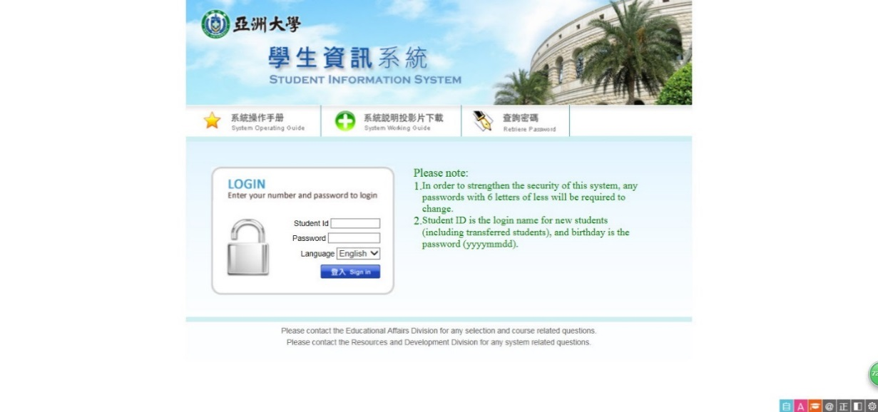
- If you have further questions, Please contact Course Division (extension 3114, 3116, 3110, 3111, 3120, 3131) or Information Office (extension 3511).

